Cost effective robots for smart precision spraying
Insert document title
Insert subtitle here
This project has received funding from the European Union’s Horizon 2020 research and innovation programme under Grant Agreement nº xxxxx .

Index
1. Title 1 5
1.1 Title 2 5
1.1.1 Title 3 5
2. Title 1 7
2.1 Title 2 7
3. Title 1 9
3.1 Title 2 9
4. Title 1 11
4.1 Title 2 11
5. Title 1 13

Index of Tables
Table 1 - Insert table title here 7

Index of Figures
Figure 1 - Insert figure title here 13

Chapter 1
Insert chapter title here

Title 1
Simply dummy text of the printing and typesetting industry. Lorem Ipsum has been the industry's standard dummy text ever since the 1500s, when an unknown printer took a galley of type and scrambled it to make a type specimen book. It has survived not only five centuries, but also the leap into electronic typesetting, remaining essentially unchanged. It was popularised in the 1960s with the release of Letraset sheets containing.

Title 2
Simply dummy text of the printing and typesetting industry. Lorem Ipsum has been the industry's standard dummy text ever since the 1500s, when an unknown printer took a galley of type and scrambled it to make a type specimen book. It has survived not only five centuries, but also the leap into electronic typesetting.

Title 3
Simply dummy text of the printing and typesetting industry. Lorem Ipsum has been the industry's standard dummy text ever since the 1500s, when an unknown printer took a galley of type and scrambled it to make a type specimen book. It has survived not only five centuries, but also the leap into electronic typesetting:
- Simply dummy text of the printing;
- Simply dummy text of the printing;
- Simply dummy text of the printing.

Chapter 2
Insert chapter title here

Title 1
Simply dummy text of the printing and typesetting industry. Lorem Ipsum has been the industry's standard dummy text ever since the 1500s, when an unknown printer took a galley of type and scrambled it to make a type specimen book. It has survived not only five centuries, but also the leap into electronic typesetting, remaining essentially unchanged. It was popularised in the 1960s with the release of Letraset sheets containing Lorem Ipsum passages, and more recently with desktop publishing software like Aldus PageMaker including versions of Lorem Ipsum.
Table 1 - Insert table title here
Lorem Ipsum | Lorem Ipsum | Lorem Ipsum | Lorem Ipsum | Lorem Ipsum
Lorem Ipsum | Lorem Ipsum | Lorem Ipsum | Lorem Ipsum | Lorem Ipsum
Lorem Ipsum | Lorem Ipsum | Lorem Ipsum | Lorem Ipsum | Lorem Ipsum
Lorem Ipsum | Lorem Ipsum | Lorem Ipsum | Lorem Ipsum | Lorem Ipsum
Lorem Ipsum | Lorem Ipsum | Lorem Ipsum | Lorem Ipsum | Lorem Ipsum

Title 2
Simply dummy text of the printing and typesetting industry. Lorem Ipsum has been the industry's standard dummy text ever since the 1500s, when an unknown printer took a galley of type and scrambled it to make a type specimen book. It has survived not only five centuries, but also the leap into electronic typesetting, remaining essentially unchanged.

Chapter 3
Insert chapter title here

Title 1
Simply dummy text of the printing and typesetting industry. Lorem Ipsum has been the industry's standard dummy text ever since the 1500s, when an unknown printer took a galley of type and scrambled it to make a type specimen book. It has survived not only five centuries, but also the leap into electronic typesetting, remaining essentially unchanged. It was popularised in the 1960s with the release of Letraset sheets containing Lorem Ipsum passages, and more recently with desktop publishing software like Aldus PageMaker including versions of Lorem Ipsum

Title 2
Simply dummy text of the printing and typesetting industry. Lorem Ipsum has been the industry's standard dummy text ever since the 1500s, when an unknown printer took a galley of type and scrambled it to make a type specimen book. It has survived not only five centuries, but also the leap into electronic typesetting, remaining essentially unchanged. It was popularised in the 1960s with the release of Letraset sheets containing Lorem Ipsum passages, and more recently with desktop publishing software like Aldus PageMaker including versions of Lorem Ipsum.
Graphic 1 - Title

Chapter 4
Insert chapter title here

Title 1
Simply dummy text of the printing and typesetting industry. Lorem Ipsum has been the industry's standard dummy text ever since the 1500s, when an unknown printer took a galley of type and scrambled it to make a type specimen book. It has survived not only five centuries, but also the leap into electronic typesetting, remaining essentially unchanged. It was popularised in the 1960s with the release of Letraset sheets containing Lorem Ipsum passages, and more recently with desktop publishing software like Aldus PageMaker including versions of Lorem Ipsum:

Title 2
Simply dummy text of the printing and typesetting industry. Lorem Ipsum has been the industry's standard dummy text ever since the 1500s, when an unknown printer took a galley of type and scrambled it to make a type specimen book. It has survived not only five centuries, but also the leap into electronic typesetting, remaining essentially unchanged. It was popularised in the 1960s with the release of Letraset sheets containing Lorem Ipsum passages, and more recently with desktop publishing software like Aldus PageMaker including versions of Lorem Ipsum:
- Simply dummy text of the printing and typesetting industry. Lorem Ipsum has been the industry's standard dummy text ever since the 1500s, when an unknown printer took a galley of type and scrambled it to make a type specimen book.

Chapter 5
Insert chapter title here

Title 1
Simply dummy text of the printing and typesetting industry. Lorem Ipsum has been the industry's standard dummy text ever since the 1500s, when an unknown printer took a galley of type and scrambled it to make a type specimen book. It has survived not only five centuries, but also the leap into electronic typesetting, remaining essentially unchanged. It was popularised in the 1960s with the release of Letraset sheets containing Lorem Ipsum passages, and more recently with desktop publishing software like Aldus PageMaker including versions of Lorem Ipsum.
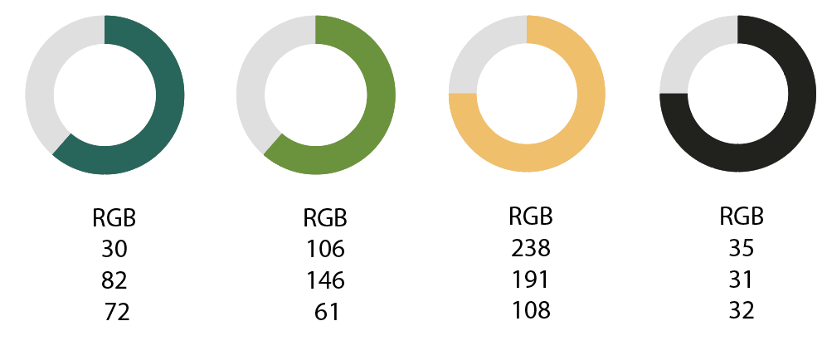
Figure 1 - Insert figure title here
Simply dummy text of the printing and typesetting industry. Lorem Ipsum has been the industry's standard dummy text ever since the 1500s, when an unknown printer took a galley of type and scrambled it to make a type specimen book. It has survived not only five centuries, but also the leap into electronic typesetting, remaining essentially unchanged. It was popularised in the 1960s.

